Goal Setting: Creating SMART Goals
A goal is a clear statement of an intended improvement and how it will be measured. Your goal should answer the question, “What do you want to accomplish?” A goal should be short enough for everyone to remember. Well-written goals should also be SMART:
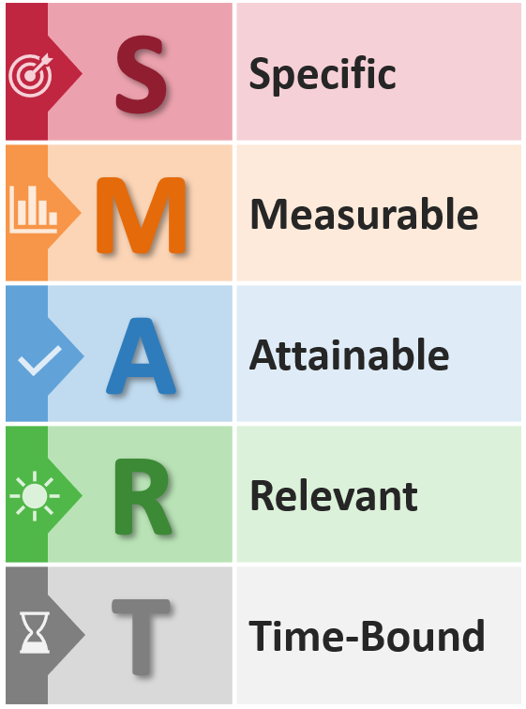
Post your goal as a visible reminder for all staff members. Use it to stay focused, establish boundaries for what is and is not included, and define your success. Write your goal in the space below.
Example: Over the next two months, increase the number of care plans that provide for medication on a regular schedule from 50 percent to 75 percent (e.g., around the clock, not just PRN*) for residents with daily pain.

Our Goal
____________________________________________________________________________________________________________________________________________________________________________________________________________________________________________________________________________________________________________________________________________________________________________
*PRN = as needed
This material was prepared by Health Services Advisory Group (HSAG) Hospital Quality Improvement Contractor (HQIC), under contract with the Centers for Medicare & Medicaid Services (CMS), an agency of the U.S. Department of Health and Human Services. The contents presented do not necessarily reflect CMS policy. Publication No. XS-HQIC-QI-06032021-01

