
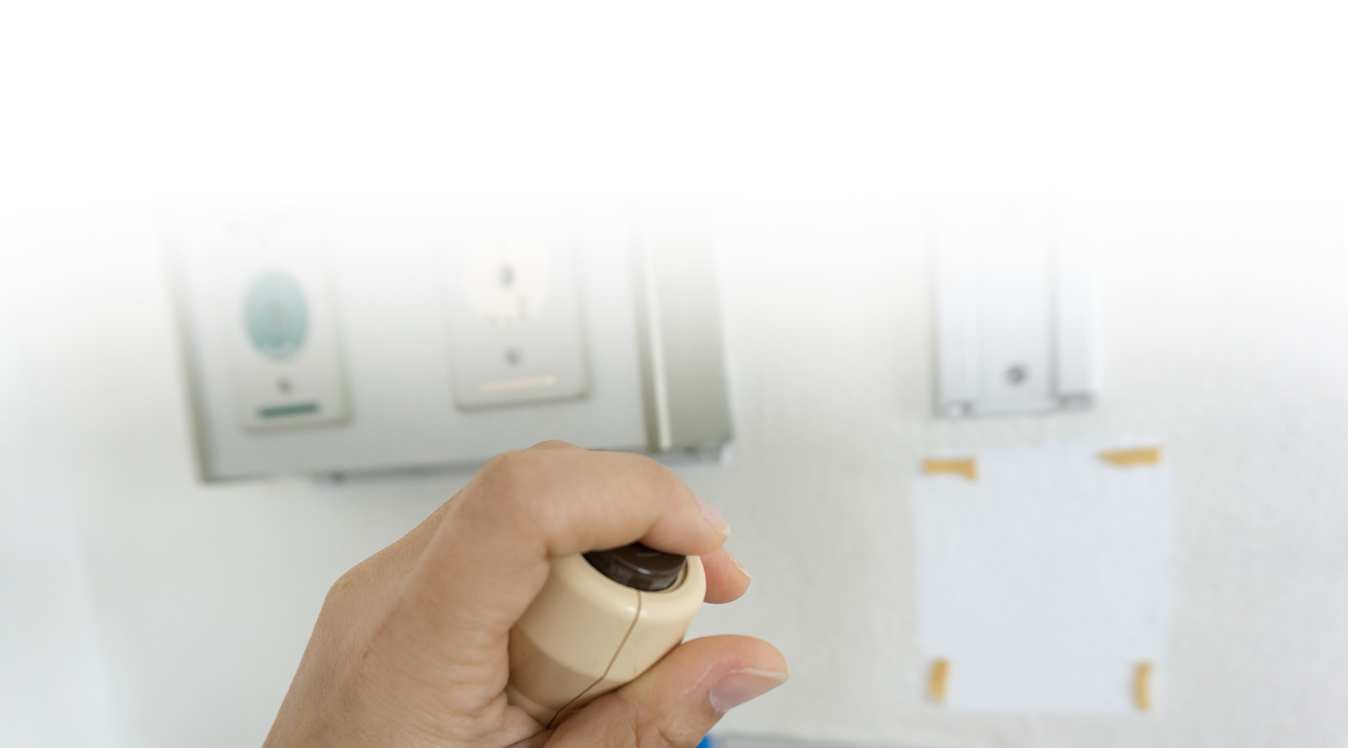
ALL staff, ALL call lights,
ALL the time.
Our team works together to keep you safe,
comfortable, and cared for.

What This Means for You:
We Work as  a Team | Help is On  the Way | No Request is  Too Small
Every staff  member is committed to answering your  call light. | The nearest  staff member  will respond,  no matter  his or her job. | If someone cannot help  right away, he or she will get the right person.
Your care is our priority.

